The 10th Distinguished Speaker Series on Electronic Data Capture
and Clinical Data Management Systems:
------Cloud Computing/SaaS and Data Bank
This presentation provides an introduction of Cloud Computing (as well as Software as a Service (SaaS)) and notion of data bank.
Software as a Service (SaaS) is evolving as the preferred model for many life sciences companies. These new paradigms are challenging the traditional approaches that have been taken to the overall validation of such computerized system solutions. This presentation outlines a revised - and, in some cases, a contrasting - approach of validation that enhances development and operational efficiencies whilst still maintaining the key requirements and expectations of sponsors, regulators and other stakeholders in the highly regulated environment in which we operate.
Data bank is a new notion, with the features of safety, synchronization and professional. Data bank is extension and innovation of data management in clinical trials. Data can be saved and management under the service of professional team and advanced technologies, to achieving the goal of protecting and growing value.
Please join us for this complimentary tenth seminar in Distinguished Speaker Series, sponsored by the Medidata Center for Clinical Research Technologies at Peking University. Through an example trial in this speaking series, participants could learn best practices for using EDC/Cloud Computing in Life Sciences Industry.
Date: Saturday, May 18, 2013, 8:30am-12:00pm
Location: Yifu Building 209
Agenda:
8:30-9:00 | Arrival & Registration
9:00-9:05 | Chen Yao, Prof, Associate Director of Peking University Clinical Research Institute | Welcome
9:05-9:50 | Tony Hewer  Senior Director, QI & Reg Affairs  Medidata Solutions Worldwide | Cloud Computing and SaaS  -An Introduction
9:50-10:35 | Yao Chen  Prof, Associate Director of  Peking University Clinical Research Institute | Storage and Management of data in Clinical Research--- the notion of data bank
10:35-11:00 | Coffee Break
11:00-11:45 | Tony Hewer  Senior Director, QI & Reg Affairs  Medidata Solutions Worldwide | Using Cloud Computing in the Life Sciences Industry
11:45-12:00 | Q&A
Registration:
Website: http://pucri.bjmu.edu.cn
Contact Person: Ms. Yan Xu
E-mail: xuyan_pucri@bjmu.edu.cn
Ph.: 010-82805563, 010-82805564
Fax: 010-6201-5547
Deadline for registration: May 17, 2013
Direction:
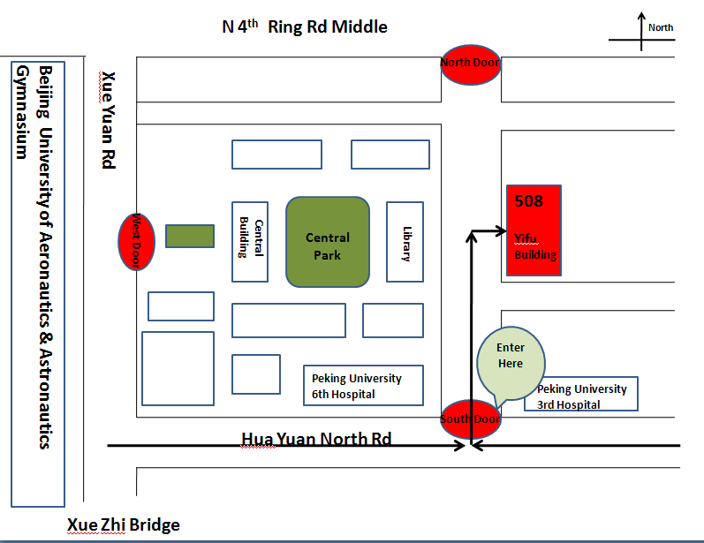

Peking University Clinical Research Institute
April 1, 2013

“电子数据采集及临床数据管理系统”专家系列讲座(第十讲)
-----------云计算、软件即服务的模式及数据银行

本次讲座将介绍云计算的概念(软件即服务的模式)和数据银行的理念。

软件即服务(SaaS)的模式正成为许多生命科学公司优先选择的模式。这些新的范例对传统的经过总体验证的计算机解决方法产生挑战。本次讲座将概述了一个修改的，甚至在某些情况下完全不同的，计算机系统解决方案的验证方法，而这个方法能在依旧满足申办者、法规监管者或其他利益相关者的主要诉求和期望的前提下，在高度规范化的工作环境中提高工作效率。

数据银行是在对于数据管理的新理念，具有安全性、同步性、专业性的特点。数据银行是临床试验数据管理理念在科研领域范围内的延伸和创新，通过专业的人员团队和先进的数据管理技术，使研究者的数据得到安全的保存，妥善的管理，达到保值，甚至增值的目的。

欢迎各位届时参加北京大学临床技术研究所Medidata中心举办的“电子数据采集及临床数据管理系统专家系列讲座”(第十讲)。通过演讲中的实例，您将可以了解到在生物科学行业内，使用电子数据采集/云计算的最佳规范。

时间：2013年5月18日（周六），上午8：30-12：00
地点：北京市海淀区学院路38号，北京大学医学部逸夫教学楼209教室

日程：
8:30-9:00 | 登记注册
9:00-9:05 | 姚晨，教授，副所长  北京大学临床研究所 | 致欢迎辞
9:05-9:50 | Tony Hewer  Medidata公司质量标准和 监管事务部资深主任 | 云计算和软件即服务的模式简介
9:50-10:35 | 姚晨，教授，副所长  北京大学临床研究所 | 临床研究数据的存储与管理----数据银行的理念
10:35-11:00 | 茶歇
11:00-11:45 | Tony Hewer  Medidata公司质量标准和 监管事务部资深主任 | 云计算在生命科学行业中的应用
11:45-12:00 | 问题讨论和解答

注册方式：
网址：http://pucri.bjmu.edu.cn
联系人：徐岩

E-mail：xuyan_pucri@bjmu.edu.cn
电话：010-82805563，010-82805564
传真：010-6201-5547
注册截止日期：2013年5月17日
论坛地点：
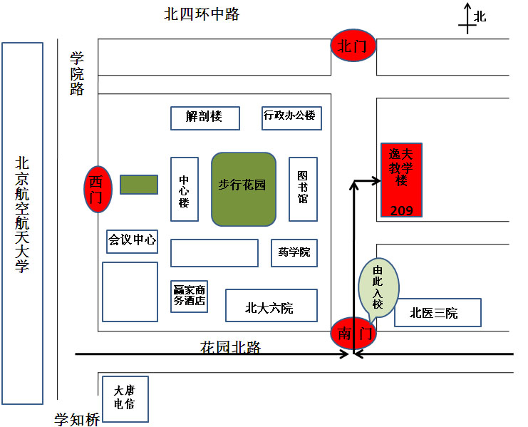
北京大学临床研究所论坛组委会
二○一三年四月一日

